Name: ___________________________________________________________________________________________________________________________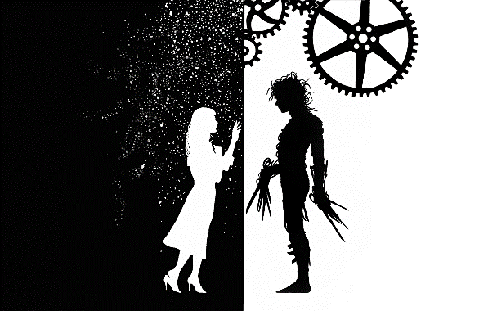
Complete the graphic organizer and final analysis paragraph as you view Tim Burton’s Edward Scissorhands. Be sure that your “Interpretation” responses are complete sentences. Consider why Burton chose these specific cinematic techniques and their effect on the film. Draw conclusions about Tim Burton’s cinematic style. How is a director’s style in a film similar to an author’s style in his/her writing?
Segment of Film  Your teacher will assign segments of the film for you to analyze. | Observations: What do you see in this scene? What cinematic techniques are used in this scene? | Interpretation: What is the effect of this/these cinematic technique(s)?
Example: The Opening Credits | Low/dim lighting  Snow falling  A castle  Scientific instruments  Cut-out shapes – hearts, cookies  Hands  Faces  Close-up shot  All spinning toward the camera  Cheerful then scary music | In the opening credits, Tim Burton uses dim lighting, close-up camera shots, and cheerful and frightening music to create a dark tone and contradictory feelings of cheerfulness and scariness.
Segment of Film  Your teacher will assign segments of the film for you to analyze. | Observations: What do you see in this scene? What cinematic techniques are used in this scene? | Interpretation: What is the effect of this/these cinematic technique(s)?
Final Analysis: Using your observations and conclusions above, choose one of Burton’s cinematic techniques and write an explanatory paragraph about how Burton uses that specific technique. In your reflective commentary, show the relationship between your claim and the evidence that supports it. Your reflections should logically extend your explanation of the technique and its effect.
_________________________________________________________________________________________________________________________________________________________________________________________________________________________________________________________________________________________________________________________________________________________________________________________________________________________________________________________________________________________________________________________________________________________________________________________________________________________________________________________________________________________________________________________________________________________________________________________________________________________________________________________

